TITLE: Style: Times New Roman 13 pt, bold, uppercase. Alignment: Centered. Line spacing: Single. Length should be limited to two lines.

F. Authorª , S. Author^{b} and F. T. Authorª

ªDepartment of Physics, Tehran University, P.O. Box 16754-4468 Tehran, Iran

General Remarks
Abstract should contain a short Introduction and the aim of the talk. The whole abstract should be written at maximum one page with a top margin of 3.5 cm and bottom, left and right margins of 2.5 cm. The text should be typeset in 12 pt. Times New Roman with 1.15 line spacing. Headings should be typeset in 12 pt. Times New Roman, boldface with the first letter of important words capitalized.
Figures
Figures may be inserted in the abstract text.
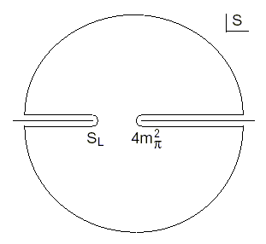
Fig. 1. This is the caption for the figure. If the caption is more than one line it needs to be manually justified.
References
Indicate references by numbers in square brackets in line with the text. The actual authors can be referred to, but the reference numbers must always be given. Example: "..... as demonstrated [3,6]. Barnaby and Jones [8] obtained a different result ...."
Examples:
Reference to a journal publication:
[1] F. Molani, J.M. Schofield, Am. J. Phys. 91, 598 (2013).
Reference to a book:
[2] B. Parsi, Computer Simulations, Tehran University Press (2011).

Corresponding author. Email: ????@?????

